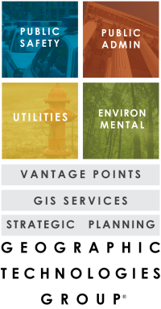

1202 Parkway Drive
Goldsboro, NC 27534
P.O. Box 10135
Goldsboro, NC 27532
(919) 759-9214 Tel
(919) 759-0410 Fax
FOR IMMEDIATE RELEASE
Murrieta, CA Deploys GeoBlade Suite for Public Safety GIS

GOLDSBORO, N.C. – Geographic Technologies Group (GTG)
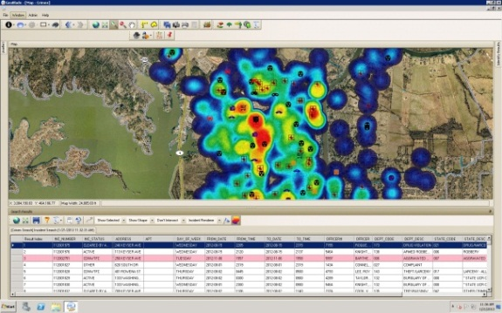
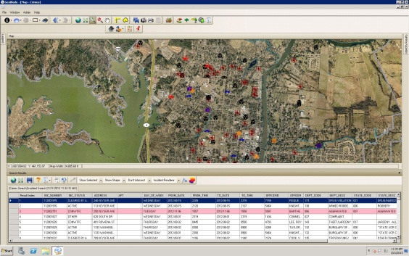
GIS capabilities for public safety agencies have advanced significantly over the last few years. The City of Murrieta, CA Police Department has continued to upgrade their technology to ensure that they have the latest tools. Murrieta recently moved to a new computer aided dispatch (CAD) vendor (Cyrun – Scotts Valley, CA). Murrieta had recently deployed a suite of ArcGIS Server based public safety tools from Geographic Technologies Group (GTG) and wanted to continue to leverage this investment. Murrieta staff approached Cyrun and GTG to inquire as to the portability of their existing GeoBlade public safety suite. Cyrun and GTG worked together to make sure that GeoBlade Dispatch, GeoBlade AVL, GeoBlade Crimes and GeoBlade Mobile were integrated with the Cyrun CAD and RMS. The City has spent a considerable amount of effort on their GIS initiatives helping first responders, dispatchers, and officers carry out their duties ensuring officer and citizen safety. By leveraging GeoBlade Dispatch, GeoBlade Mobile, GeoBlade AVL, and GeoBlade Crimes, Murrieta’s police department continues to have the right software to make intelligent, timely decisions.

The GeoBlade suite allows a seamless sharing of data between all users within the Police Department. By leveraging Esri’s ArcGIS Server and connecting to their Cyrun CAD and RMS platforms, GeoBlade displays mission critical information to help Police and Fire officers save time, money, and lives. First responders in the field now show Cyrun calls for service along with Automatic Vehicle Location (AVL) via a touch-screen environment with GeoBlade Mobile. GeoBlade Dispatch provides a host of critical data to the Murrieta dispatchers along with a robust set of GIS functionality to assist the officers while they are en-route. GeoBlade Crimes is leveraged by the crime analysts and shift commanders to identify crime trends.

GTG is the winner of the 2011 Esri International Mobile GIS Application Award and the 2012 Esri Special Achievement in GIS Award.

Please contact James Kelt at 1-888-757-4222 or email jkelt@geotg.com for more information.

About Geographic Technologies Group, Inc. (GTG):
GTG is a full-service local government GIS consulting company offering specialized experience in the planning, design, implementation, and procurement of geo-technologies. GTG has unmatched technical GIS capabilities, demonstrated successes, international experience, and a reputation for successfully implementing the right solutions. GTG develops GIS products that spatially enable various enterprise solutions and integrates an organization's IT investment via a common interface. GTG also offers stand-alone products for land management, public safety, public access, touch screen technology, and utilities.

GTG has more than 700 clients located throughout North America and Europe and serves all levels of government as well as the private sector. To support our clients, GTG maintains four offices located across the United States: Headquarters in North Carolina, and regional offices in Texas, Florida, Ohio, and California.

Additional information may be obtained by contacting Geographic Technologies Group, Inc. at 888-757-4222 or you can access our website at www.geotg.com.
####

