1202 Parkway Drive
Goldsboro, NC 27534
P.O. Box 10135
Goldsboro, NC 27532
(919) 759-9214 Tel
(919) 759-0410 Fax
FOR IMMEDIATE RELEASE
Harnett County, NC Utilizes GTG’s MapNimbus to Inform Citizens of Crime Information

GOLDSBORO, N.C. – Geographic Technologies Group (GTG) welcomes Harnett County, N.C. to the community of MapNimbus users. MapNimbus an easy-to-use online mapping solution for the public that provides citizens with information on what is happening in their community. Harnett County is currently using MapNimbus to show crime and sex offender data.

MapNimbus is an easy-to-use Esri-based interface that allows the public to view information in a variety of categories, including crime activity and sex offender data. It offers dynamic reporting tools that allow users to quickly analyze events that have occurred within a particular time.

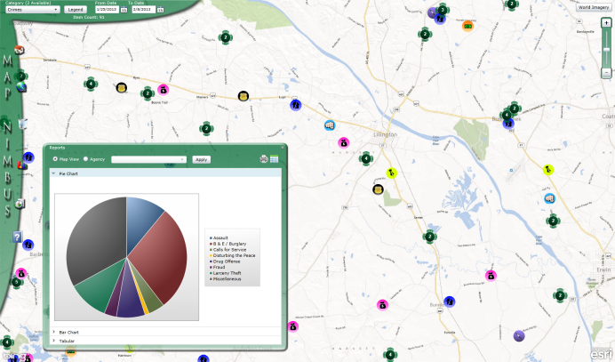
MapNimbus has intuitive search capabilities allowing users to search by address or general location, such as parks or schools. MapNimbus also includes e-mail notification capabilities. MapNimbus will automatically e-mail users if there is an update within their predefined area, such as near their home or children’s school.

“GTG is excited to implement MapNimbus in Harnett County,” said Matthew McLamb, Sales and Marketing Manager at GTG. “MapNimbus will help the County to continue promoting a safer and better community for their citizens. With the ability to map a wide variety of information in a single, easy-to-use public Web portal, MapNimbus will get citizens involved and excited about what is happening in their community.”

MapNimbus will provide a noticeable return-on-investment at Harnett County, saving time and valuable resources for both citizens and County personnel. It gives citizens access to important and relevant information.

MapNimbus is free to the public. Harnett County citizens can experience MapNimbus by clicking the following link: Harnett County MapNimbus

For more information on how MapNimbus can benefit your community, visit www.geotg.com or contact Matthew McLamb at 919-759-9214 or mmclamb@geotg.com.

About Geographic Technologies Group, Inc. (GTG):
GTG is a full-service local government GIS consulting company offering specialized experience in the planning, design, implementation, and procurement of geo-technologies. GTG has unmatched technical GIS capabilities, demonstrated successes, international experience, and a reputation for successfully implementing the right solutions. GTG develops GIS products that spatially enable various enterprise solutions and integrates an organization's IT investment via a common interface. GTG also offers stand-alone products for land management, public safety, public access, touch screen technology, and utilities.

GTG has more than 700 clients located throughout North America and Europe and serves all levels of government as well as the private sector. To support our clients, GTG maintains four offices located across the United States: Headquarters in North Carolina, and regional offices in Texas, Florida, Ohio, and California.

Additional information may be obtained by contacting Geographic Technologies Group, Inc. at 888-757-4222 or you can access our website at www.geotg.com.
####

