[www.catcomtec.com]
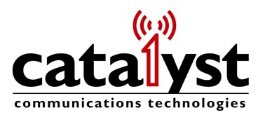
U____________________________________press release

Catalyst Awarded DHS LMR Contract
Five Year Ordering Period for DHS, DOI, DOJ, DOS & WHCA Agencies

March 28, 2012
FOREST, Va. -- Catalyst Communications Technologies, Inc. (Catalyst) announced today it was awarded a prime contract by the Department of Homeland Security (DHS) to provide various types of Radio Dispatch Console equipment in support of Federal Land Mobile Radio (LMR) systems. The multiple-award indefinite-delivery/indefinite-quantity (IDIQ) ordering period will be five years -- a two-year base period plus three one-year option periods. The total potential contract value is not to exceed $3 billion if all task orders and all options are exercised. The contracts are available for ordering to DHS and its components, as well as for DHS partner agencies and their subordinate components, including the White House Communications Agency, Department of Interior, Department of State, and Department of Justice.
Catalyst is a leading provider of IP based Dispatch Console and Interoperability solutions, with systems currently in service at various federal agencies including the DOI, DOJ and DOD as well as Public Safety, Utility, and other critical communications agencies. Under this contract, Catalyst will provide a wide range of Dispatch Systems under Technical Category 2 (TC2) Infrastructure that may include hardware, software, systems engineering, installation, and program management services as required per delivery order. Catalyst is one of a limited number of companies awarded the IDIQ contract to support the DHS and its Components in the purchasing of a full array of tactical communications (TacCom) products, infrastructure and services. The DHS multi-vendor approach is to help accelerate the implementation of fully interoperable LMR solutions in support of mission critical, public safety communications. Catalyst is a pioneer and leader in the deployment of LMR Interoperability solutions including its IP LinkTM and IntelliLinkTM products.
Catalyst president Robin Grier remarked, “U.S. federal agencies have been key partners to Catalyst over the last fifteen years as together we have deployed leading edge Radio over IP solutions for dispatch and interoperability. We are pleased that this IDIQ contract will simplify the ordering process for our existing federal partners, and we welcome the opportunity to serve additional agencies through it.” The company has successfully completed two U.S. Department of Agriculture Phase 1 and Phase 2 Small Business Innovation Awards focusing on interoperability and Project 25.
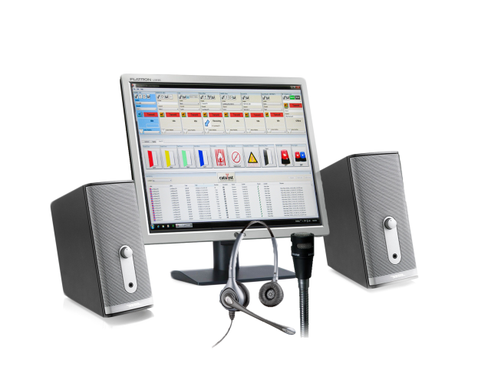
Catalyst IP|ConsoleTM

Catalyst Communications Technologies, Inc. markets Radio Control over IP technology for the Land Mobile Radio Industry and is a force for change in the effort to bring Internet-derived technologies into mobile radio applications. Catalyst focuses on products that leverage standard Windows®-based computers to reduce cost and increase the efficiency of network operators and end users. Catalyst’s extensive product line significantly enhances legacy dispatch communications systems by seamlessly bridging wireless and wireline communications networks for network-based interoperability.
IP|ConsoleTM, IP LinkTM and IntelliLinkTM are a trademarks of Catalyst Communications Technologies, Inc. MomentumTM is a trademark of Harris Corporation. Windows® is a trademark of Microsoft.
Contact Catalyst at info@catcomtec.com or (434) 582-6146 for additional information.

For editorial information, please contact:
John Kramer
Catalyst Communications Technologies, Inc.
(434) 582-6163 or jkramer@catcomtec.com

