[www.catcomtec.com]
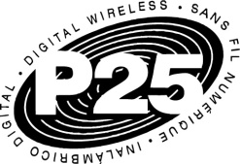

U____________________________________press release

Catalyst Announces P25 Console Subsystem Interface
Project 25 CSSI Provides Hardwire Connection for Trunked Radio Systems

December 12, 2012

IWCE Virtual Expo
Catalyst Communications Technologies, Inc., a leading provider of Radio Control over IP solutions to the Push-to-Talk (PTT) marketplace, today announced a new Console Subsystem Interface (CSSI) for its IP|ConsoleTM solution. CSSI is one of the eight primary Project 25 (P25) interfaces specified in the TIA-102 suite of standards and supports trunking. The Catalyst CSSI Gateway may be added to both new and existing IP|Console systems for voice dispatch to public safety and other critical communications agencies. With its flexible, graphical user interface, Catalyst can provide Police, Fire, EMS, utilities and others custom dispatch screens and capabilities to better meet the unique needs and budgets of each agency.

Catalyst has continued to enhance its P25 dispatch and interoperability solutions over the years and the expansion to include CSSI in its suite of products is the next logical step in this progression. Catalyst pioneered the P25 Fixed Station Interface, providing support for conventional channels, and offers a control station interface for P25 conventional and trunked systems using radios from a variety of manufacturers. “CSSI has come of age,” comments Catalyst president Robin Grier. “A critical mass of radio system manufacturers now provides a CSSI interface into their Radio Frequency Subsystems, allowing customers to choose the console that best meets their needs. By connecting via hardwire to trunked radio systems additional advanced features are now possible. Catalyst is pleased to meet the evolving requirements for innovative solutions.”

With ever tightening budgets, critical communications agencies are saving money by choosing Catalyst. Customers can add a CSSI Gateway to their existing IP|Console solution, enhancing their current capabilities by building on their initial investment. Using its field-proven Radio over IP (RoIP) technology, agencies can connect via a shared Internet Protocol network to link consoles to radio systems and other devices over a large geographic region. Using a shared network saves significant cost and simplifies maintenance.

IP|Console supports primary dispatch, backup dispatch, and mobile dispatch for Project 25, Broadband Push-To-Talk, and legacy radio systems. This flagship console provides a rich user interface that supports Unit ID, Emergency signaling, custom graphics for each talk group, a centralized alias database, roaming for dispatchers, instant playback, and control of remote devices. The first company to provide dispatch support for Broadband PTT, Catalyst has refined its solutions in preparation for emerging LTE capabilities. IP|Console also supports SMARTNET®, EDACSTM, MDC-1200, the Digital Mobile Radio (DMR) standard, Session Initiation Protocol (SIP) compatible solutions, and other systems.

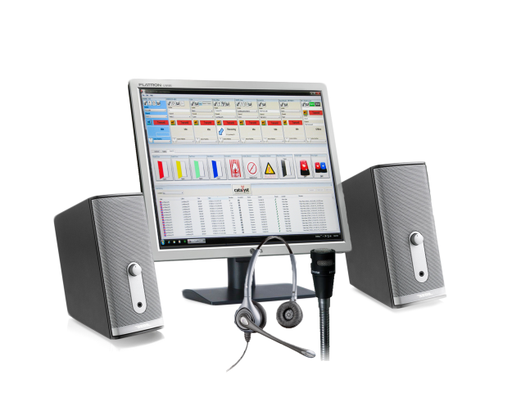

Catalyst IP|ConsoleTM

Catalyst Communications Technologies, Inc. markets Radio Control over IP technology for the Critical Communications Industry and is a force for change in the effort to bring Internet-derived technologies into mobile radio applications. Catalyst focuses on products that leverage standard Windows®-based computers to reduce cost and increase the efficiency of network operators and end users. Catalyst’s extensive product line significantly enhances legacy dispatch communications systems by seamlessly bridging wireless and wireline communications networks for network-based interoperability.

IP|Console™ is a trademark of Catalyst Communications Technologies, Inc. All other trademarks are property of their respective owners.

Contact Catalyst at info@catcomtec.com or (434) 582-6146 for additional information.

For editorial information, please contact:
John Kramer
Catalyst Communications Technologies, Inc.
(434) 582-6163 or jkramer@catcomtec.com

